**Black Scholes Option Pricing Model**

**Normal Distribution**

# Normal Distribution

* 
* 
* Special distribution where the **parameters are the mean and variances themselves**



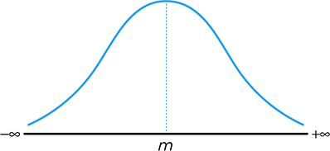

## Linear Combination of Normal Distributions

* Given two independently distributed Normal Variables, any **linear combination** of the two will be normally distributed as well
* Note that the variance will ALWAYS increase while the mean will be scaled accordingly







# Standard Normal Distribution

* 
* 

We can convert regular Normal Variables into Standard Normal Variables via **Normalization**









Note that if there is a constant,







## Standard Normal Probabilities

Probability of Z < a 
Area under the curve before a 
< a) = N(a) 
Probability ofZ > a 
Area under the curve after a 

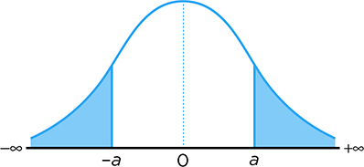











## Standard Normal Table

* 
* 
* 

## Algebraic Manipulation

* 
* 
* 
* 

**Log Normal Distribution**

# Log-Normal Distribution

* If the **natural logarithm of a variable is normally distributed**, then the original variable itself is **Log Normally distributed**
* 
* 
  + 
  + They are NOT the Mean and Variance of the Log Normal Distribution





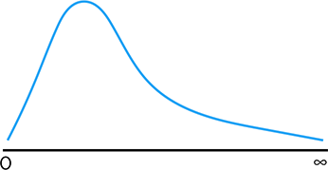

## Properties of the Log Normal Distribution

* We can use the **Moment Generating Function** of the Normal Distribution to derive the Moments for the Log Normal Distribution
* Log normal distributions are ALWAYS positive
* The **PRODUCT** of two Log Normal Variables will still be Log Normally Distributed



|  |  |
| --- | --- |
| **First Moment** | **Second Moment** |
|  |  |

# Normally Distributed Returns

* 
* The return is made of two components – **Dividend Yield and Capital Gain**











We assume that **continuous returns** are **normally distributed**

* This is because we can break the return up into the **sum of many smaller returns**
* If returns in **non-overlapping time periods** are **i.i.d.**, then the sum of these returns (Continuous return) is **approximately normal** via the **Central Limit Theorem**
  + 
  + 
  + 

# Log-Normal Stock Prices

Since the dividend yield is a **constant**,







Expressed differently,









We **consider the first moment** of the Log normal distribution:











* 
* 

Comparing both equations,





We obtain an expression for the **log-normally distributed future stock prices:**











We obtain an expression for the first two moments of a log-normal distribution:





Skipping the formal proof, we can also obtain the **Conditional Expectation**:



* 
* The logic can be understood as follows:
  + 
  + 
  + 

Similarly, we obtain an expression for the actual stock price at a given time,



* Note that this formula can be used to determine the stock price at **any period at a given percentile**
* Note that we need to convert the percentile back into the **Z value**

## Using Historical Data

* 
* We can follow the three step process to determine the parameters from historical data:

Most likely, the data will be given in **monthly format**. We will first need to convert the data into a **continuously compounded format**,



Next, we can calculate the Sample Mean and Sample Standard Deviation using the **Calculator Function**,



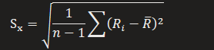

Lastly, we convert them to **ANNUAL format**,





## Relation to Forward Prices

* Logically speaking, we would only enter a forward contract if we **expect** a positive payoff from it
* Thus, Expected Stock Price should always be **larger than the Expected Stock Price**









**Black Scholes Formula**

# Option Pricing with Lognormal Stocks

|  |  |
| --- | --- |
| **Call Option** | **Put Options** |
|  |  |
| Since the **second term is always 0**, we omit it from the equation | Since the **second term is always 0**, we omit it from the equation |
| We first consider an expression for the probability: | We first consider an expression for the probability: |
| We consider an expression for the expectation (Formal proof skipped): | We consider an expression for the expectation (Formal proof skipped): |
| Combining the above terms, | Combining the above terms, |
| The price of the option is thus the **PV of the expected payoff:** | The price of the option is thus the **PV of the expected payoff:** |

# Black Scholes Formula

* 
  + These values are **not known beforehand** – so they are **purely theoretical**
* If we assume that the investor is **risk neutral –** it means that the investor **does not consider risk** in evaluating their investment decisions
  + 

Under the **Risk Neutral Assumption**,

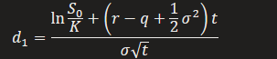

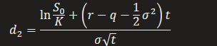



|  |  |
| --- | --- |
| **Call Option** | **Put Option** |
|  |  |

More generally, we can express it in the form of **Prepaid Forward Prices:**

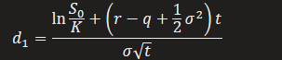

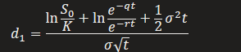

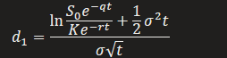

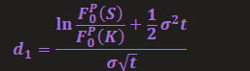

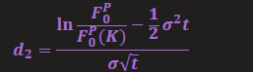

|  |  |
| --- | --- |
| **Call Option** | **Put Option** |
|  |  |











## Black Scholes Special Cases

* There are two unique scenarios in which the Black Scholes formula will be simplified - allowing for us to **solve for a specific input**

|  |  |  |
| --- | --- | --- |
| **At the Money** | **Equal Rates** | **Both Scenarios** |
|  |  |  |
|  |  |  |